//Facing problem with Centos ver.6 operating system as I tried to upgrade it to ver.7

So I am using UBUNTU Linux operating system for this assignment.

1. **Add a 10GB disk to the CentOS.**

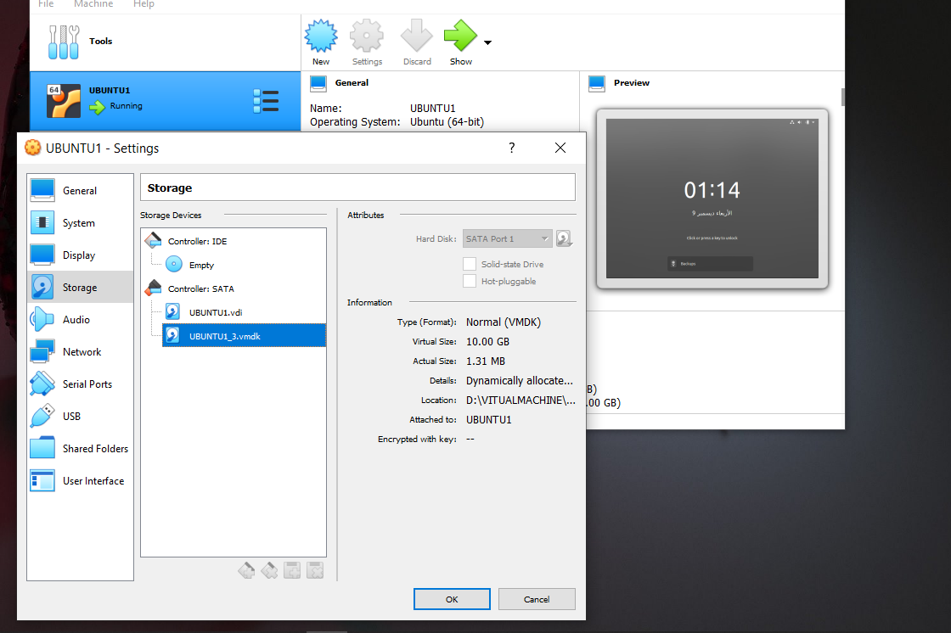

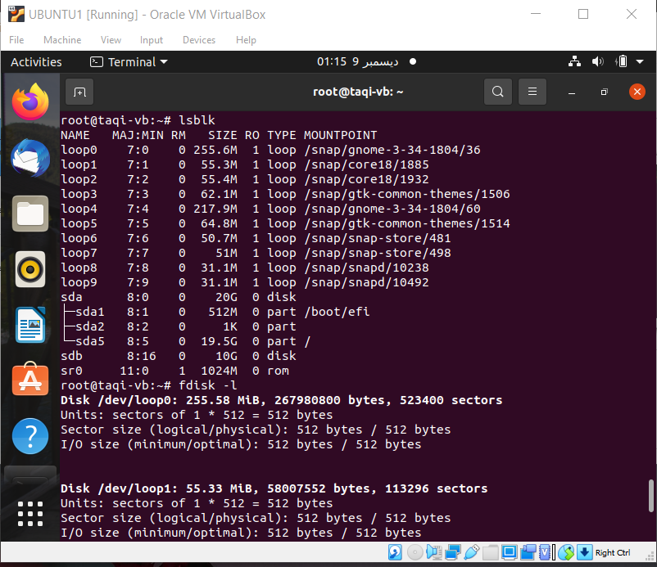

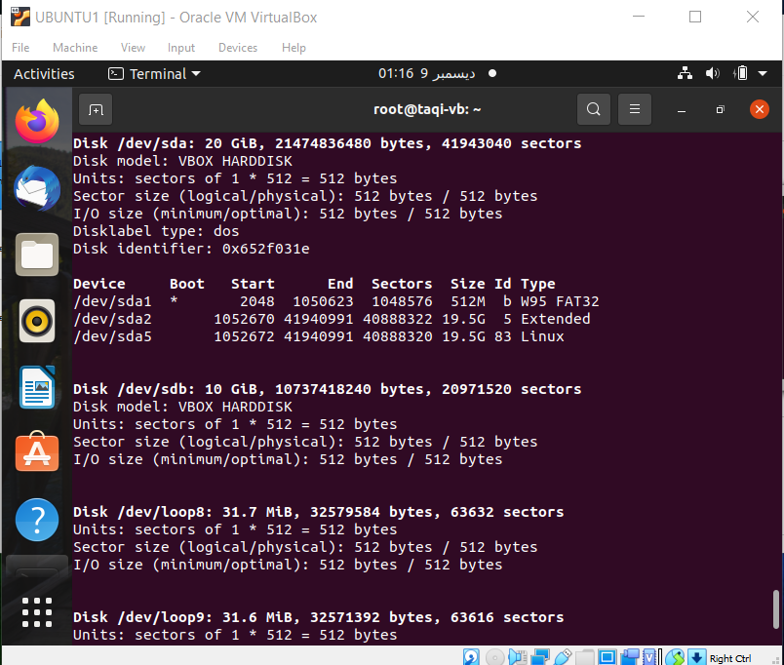

**2.Create 2 Partitions 4GB and 6GB of Space respectively.**

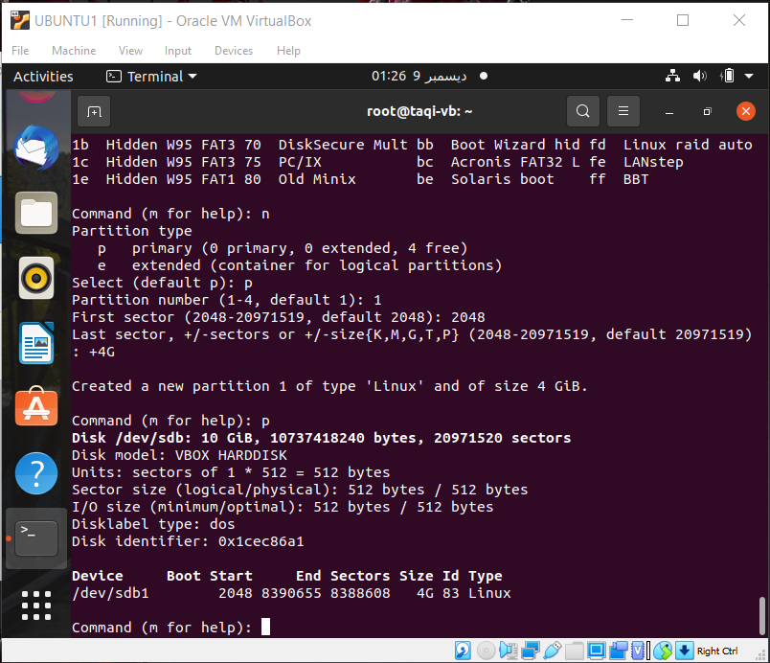

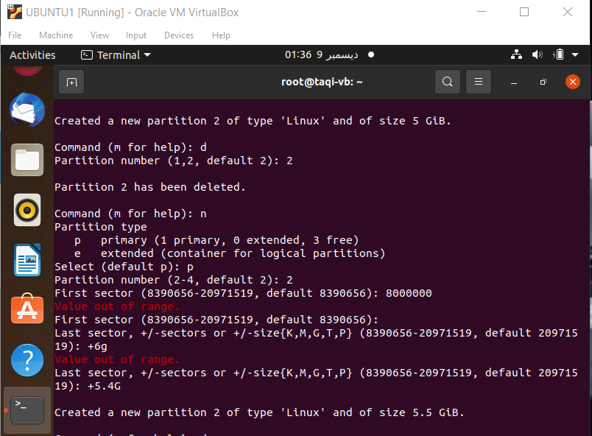

**Unable to get complete 6GB ,its giving out of range error, so I took** 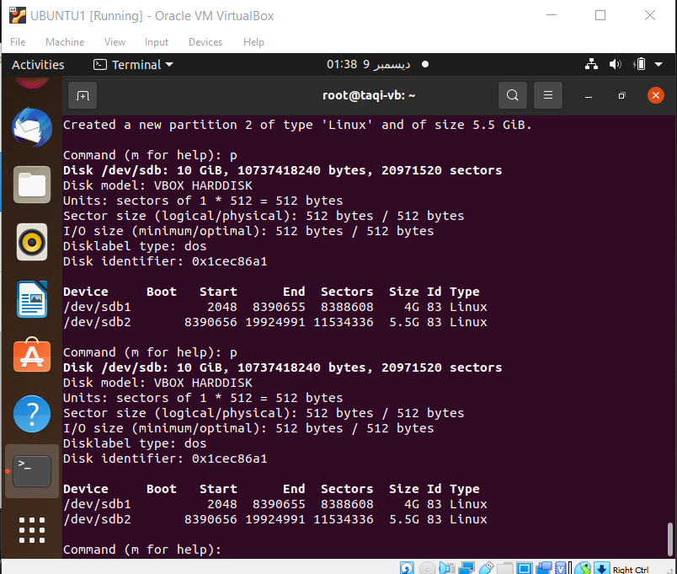

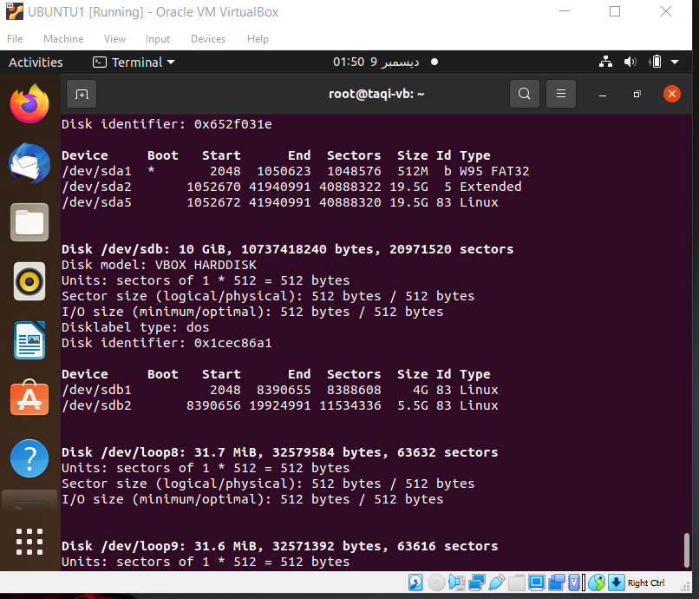

**3.Format 4GB with xfs and 6GB with ext4 file system**

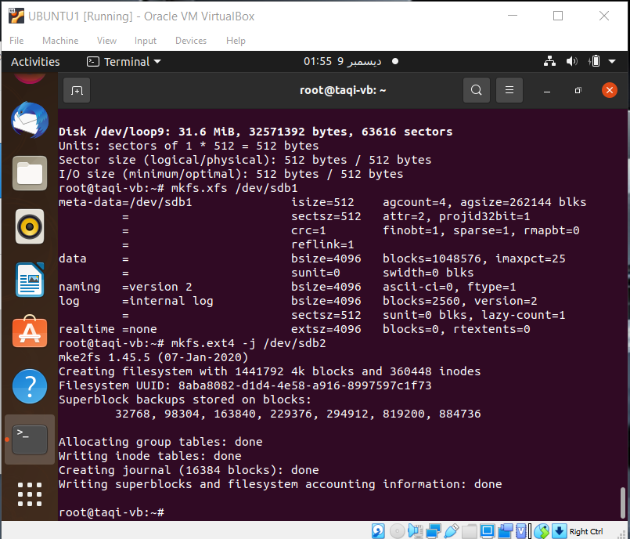

**4. Mount 4GB and 6GB in /data and /music directory respectively.**

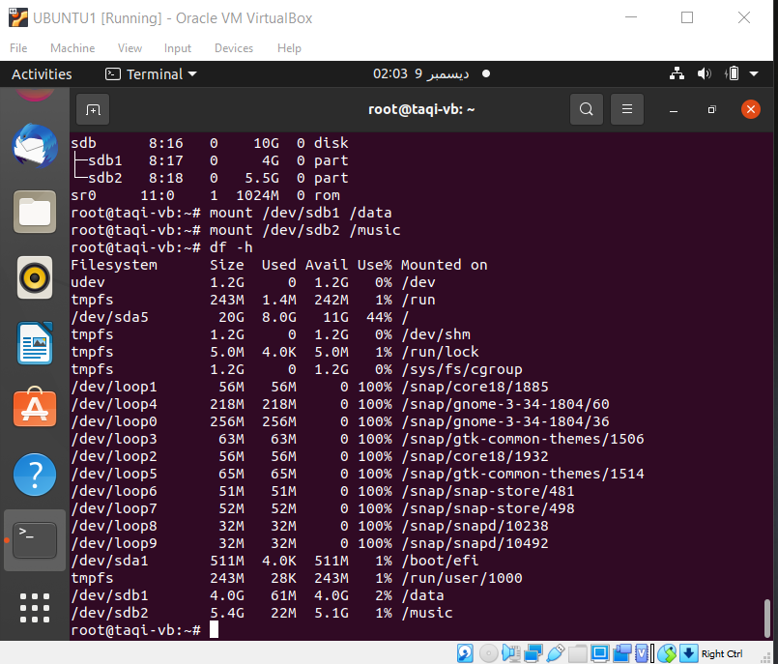

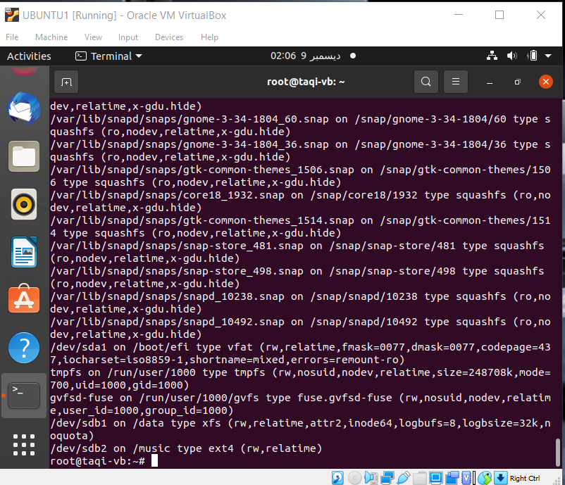

**Permenant mount**

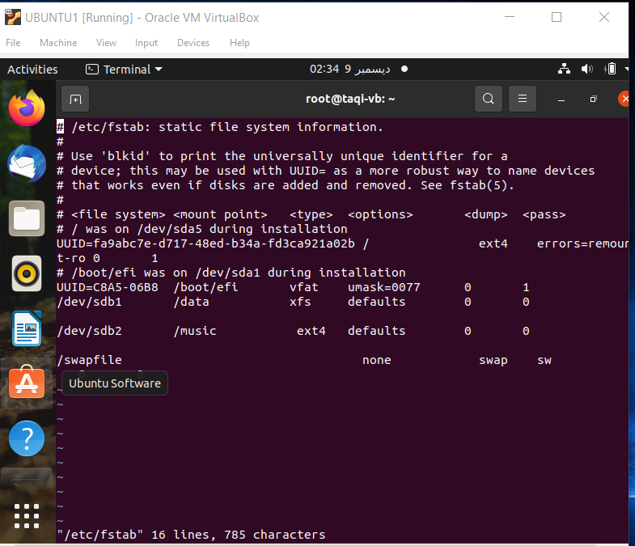

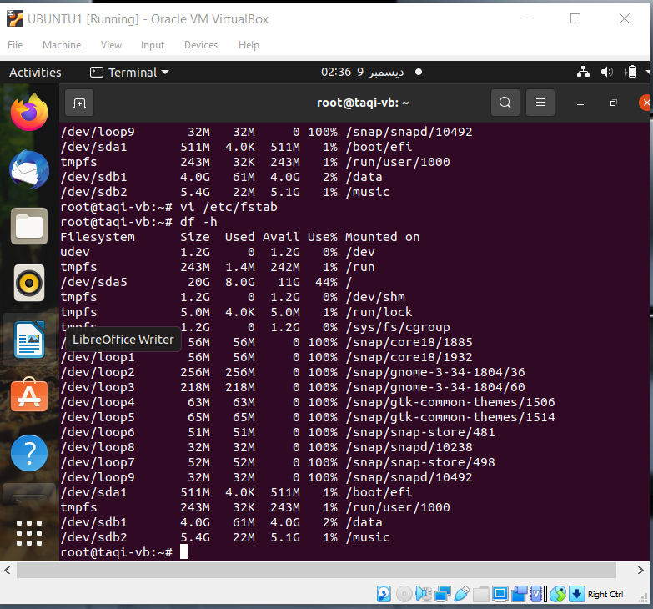

**5. Create one file of 1GB in each of the mount point created above.**

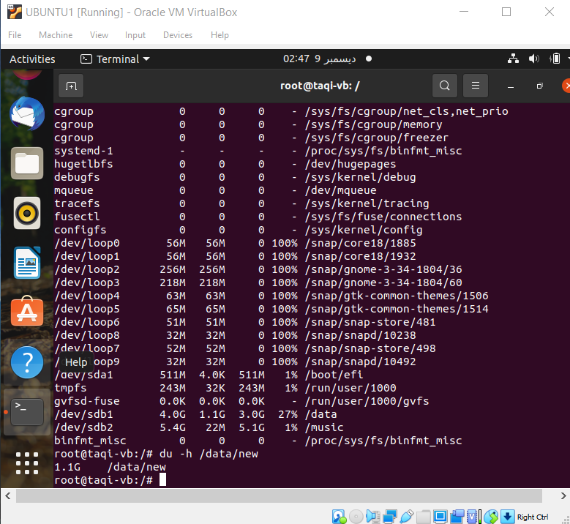

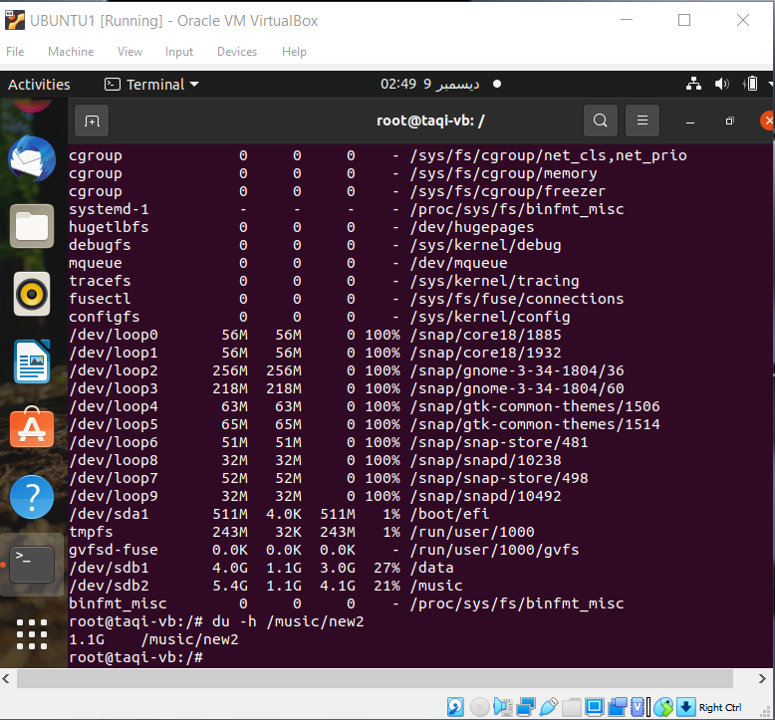

**6. Verify the disk Consumption and disk space free in the mounted partitions.**

**Using “Gparted” function**

